**Brief Analysis of the paper**

Titled: **On the complex domain deep machine learning for face recognition**

Authored by: **B. K. Tripathi**

**Inferences:**

1. Typical methods for feature extraction and dimensionality reduction are PCA and ICA. While it is observed that both methods provide a good estimate of independent features, ICA performs better than PCA in most cases. This is because it doesn't assume the data to be Gaussian (in real world data is often not distributed as a Gaussian variate).

2. Another important analysis in this paper is the use of Complex value domain instead of Real value domain. Thus, we would compare CVNNs, which use complex numbers for inputs, weights & biases, against RVNNs that use real numbers instead. For PCA and ICA, both real valued (RPCA, RICA) and complex valued (CPCA, CICA) component analysis has been done.

3. In this paper the author combines the two techniques mentioned above (CvNN and CPCA/CICA) and compares it with traditional techniques (R-MLP) to identify the performance in terms of False Recognition Rate, False Acceptance Rate and Recognition rate. We want to have high recognition rate, low false recognition rate, and even lower false acceptance rate.

4. CVNNs have been shown to outperform RVNNs even for real valued tasks. Similarly, CPCA displays higher variance as compared to RPCA. In most cases **C**ICA & **C**PCA perform better than RICA & CICA in terms of recognition rate. This justifies the use of complex value domain. CICA shows greater class discrimination ability than the others. This trend, however is not general in case of recognition rate. There are a few situations when RPCA is better than CPCA and RICA. One visible observation is that as the number of features increases RPCA's recognition rate increases monotonically. This is not seen in the other cases.

5. The paper also introduces a higher order neuron model (TION1 and TION2). Essentially these are neurons in the complex domains which can achieve higher accuracy even with **lower number of features** and a **smaller neural network**trained with **lesser number of epochs**. In these, One-Class-in-One-Neuron model is implemented wherein a single TION1 neuron can be used to identify a class (a person, in this case). An ensemble of such neurons can be used to discriminate between people, where each neuron would associate itself with a class (a person) when it is trained.

6. Results have shown that the combination of Complex-TION1 neuron with CICA outperforms all other combinations. This could be due to the use of complex domain, and a justified method of not assuming Gaussian distribution.

**Some observations not mentioned in the paper:  
  
1.** Some images which we may be recognized by the naked eye are not recognized by any of the feature extraction methods.

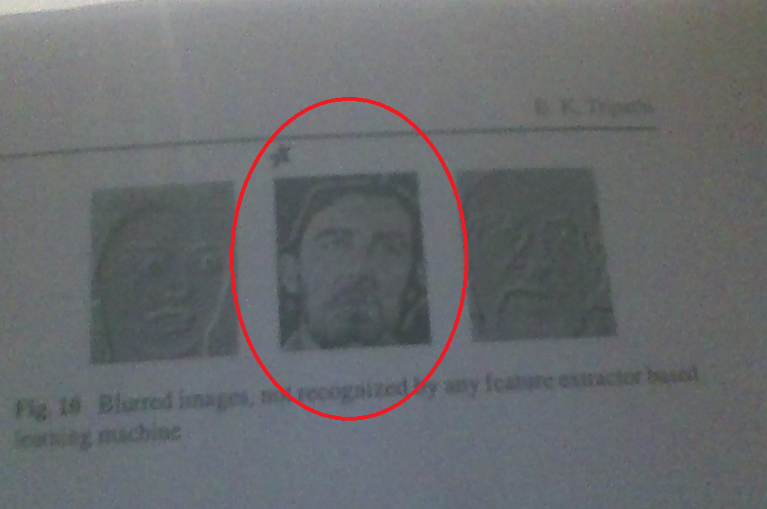

*(ref: fig 10)*

On deeper thoughts, I could identify a possible solution. Think of what humans would do. We would ignore the white lines around the hair of this person (we would imagine that contour to be a part of the hair). Similarly, other white coloured lines on the face would be ignored. However, a learning machine would consider those lines as some special features and will not be able to conclude with confidence.   
  
Here, we could introduce heuristics which help the ANN ignore such information. One such heuristic could be, “give more importance to the facial features than the hair”. Thus, deviations in the hair would be less significant than the facial features. We could extend this idea and apply it in all places where we give more importance to some specific features than others. Hence, while training the network, we could initialize it with a minimum weight for each feature. It might lead us to faster convergence with greater accuracy. However, this is something to be tested.

**2.** There are a few difficult images (with respect to our perception) recognized with a RICA based learning machine. But simpler ones with more effects are not recognized by it. Thus, what looks difficult to us, may not necessarily be difficult for the ANN to understand.

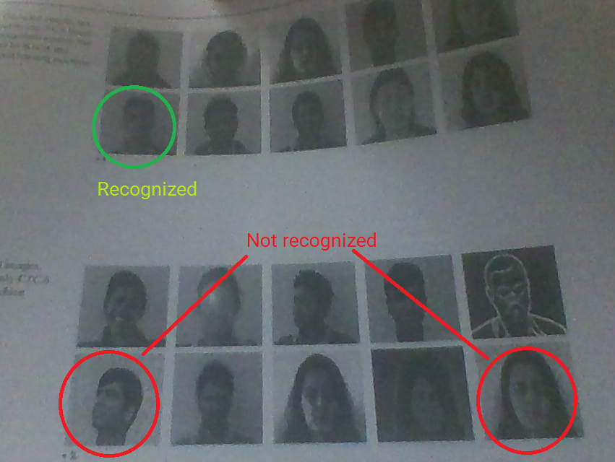

*(ref: fig 17 & 18)*

**3.** When using a simple R-MLP neuron and RPCA feature extraction, a higher number of epochs lead to a higher FAR (False Acceptance Rate) and a lower Recognition Rate. This could perhaps be a result of overfitting. *(in all the three tables, kindly look at the FAR and RR values for RMLP with RPCA).***This might also be the case with TION1 and TION2 neurons. Further investigation should be done on this.**

**Written by:**

Naveen Venkat

2015A7PS0078P